EXPERIMENT-14

AIM :TO Write PL/SQL program to implement Stored Function on table.

PL/SQL Function:

The PL/SQL Function is very similar to PL/SQL Procedure. The main difference between

procedure and a function is, a function must always return a value, and on the other hand a

procedure may or may not return a value. Except this, all the other things of PL/SQL procedure are true for PL/SQL function too.

EXAMPLE 1:

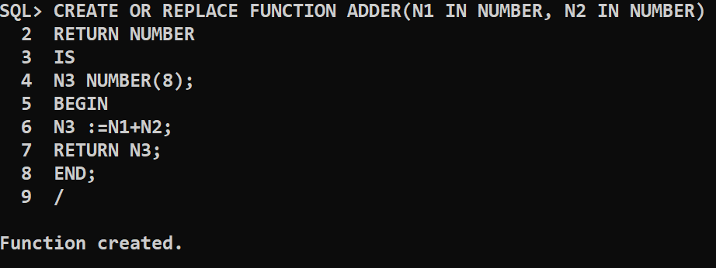

Execution Procedure:

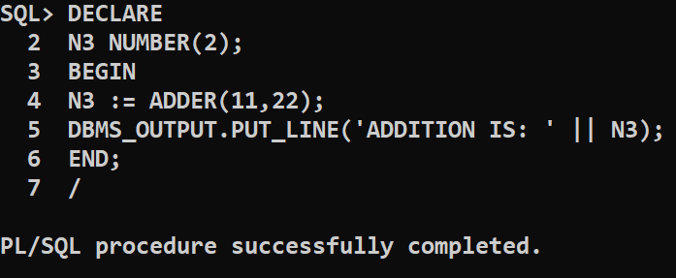

To drop function :

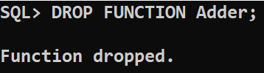

EXAMPLE : 2

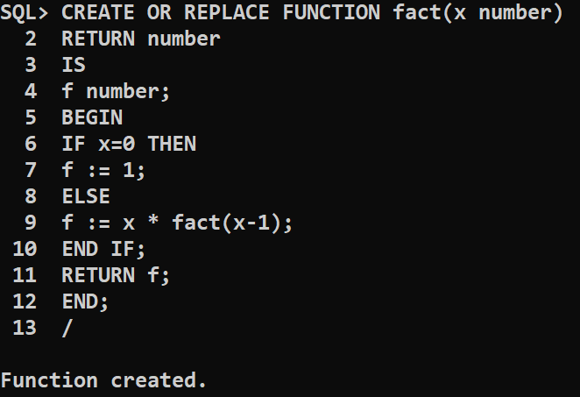

Execution Procedure:

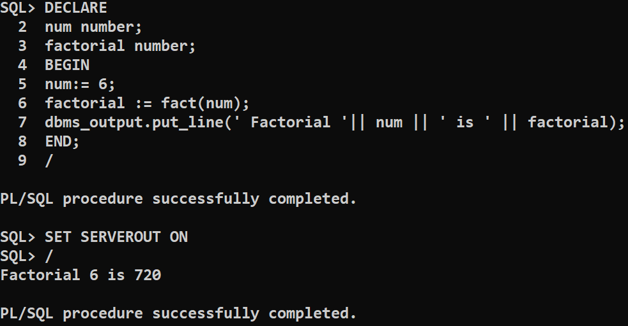

To drop function :

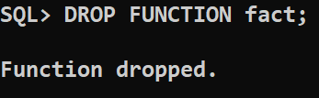

Conclusion : The PL/SQL program to implement Stored Function on table is successfully executed.